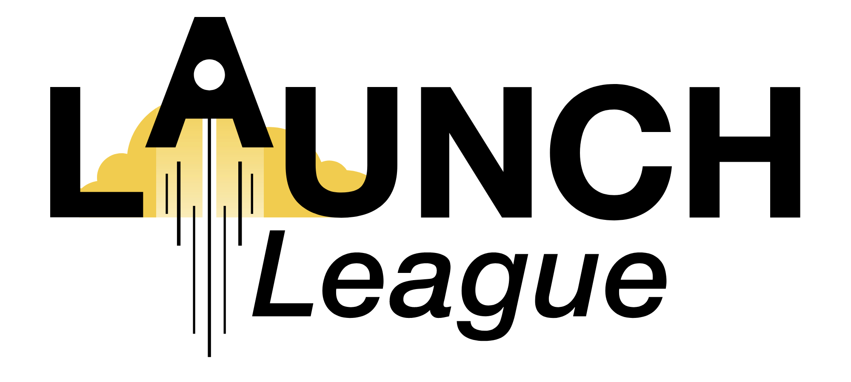
MODULE 2 EXERCISE

- Target Customers -

1. Who are your customers?
Take 3 minutes to write down as much information about your customers as you know - use bullet points and brief descriptions:

2. Relook at your points above and ask yourself if you have described more than one group of customers and if you have included information about your users as well.
If you have described more than one group, or included information about users, make notes next to each point e.g. 1 = target customer group one; u = user etc.
3. Now select your main customer group and use the questions to order and add to the information you have about your customer.
If you have more than one target customer or users as well you may need to do this a few times.
Target Customer
Gender, Age etc.
Social & economic information.
– Include info on income, employment, use of technology, social media etc.

Why are they buying/ would they buy your product or services?

Once you are happy with this customer description, you can re-write it into your canvas in the Star Quality block. (Only use your main target customer for the canvas!)

After the Bootcamp, you should go out and speak to customers/ potential customers to find out more about them!

