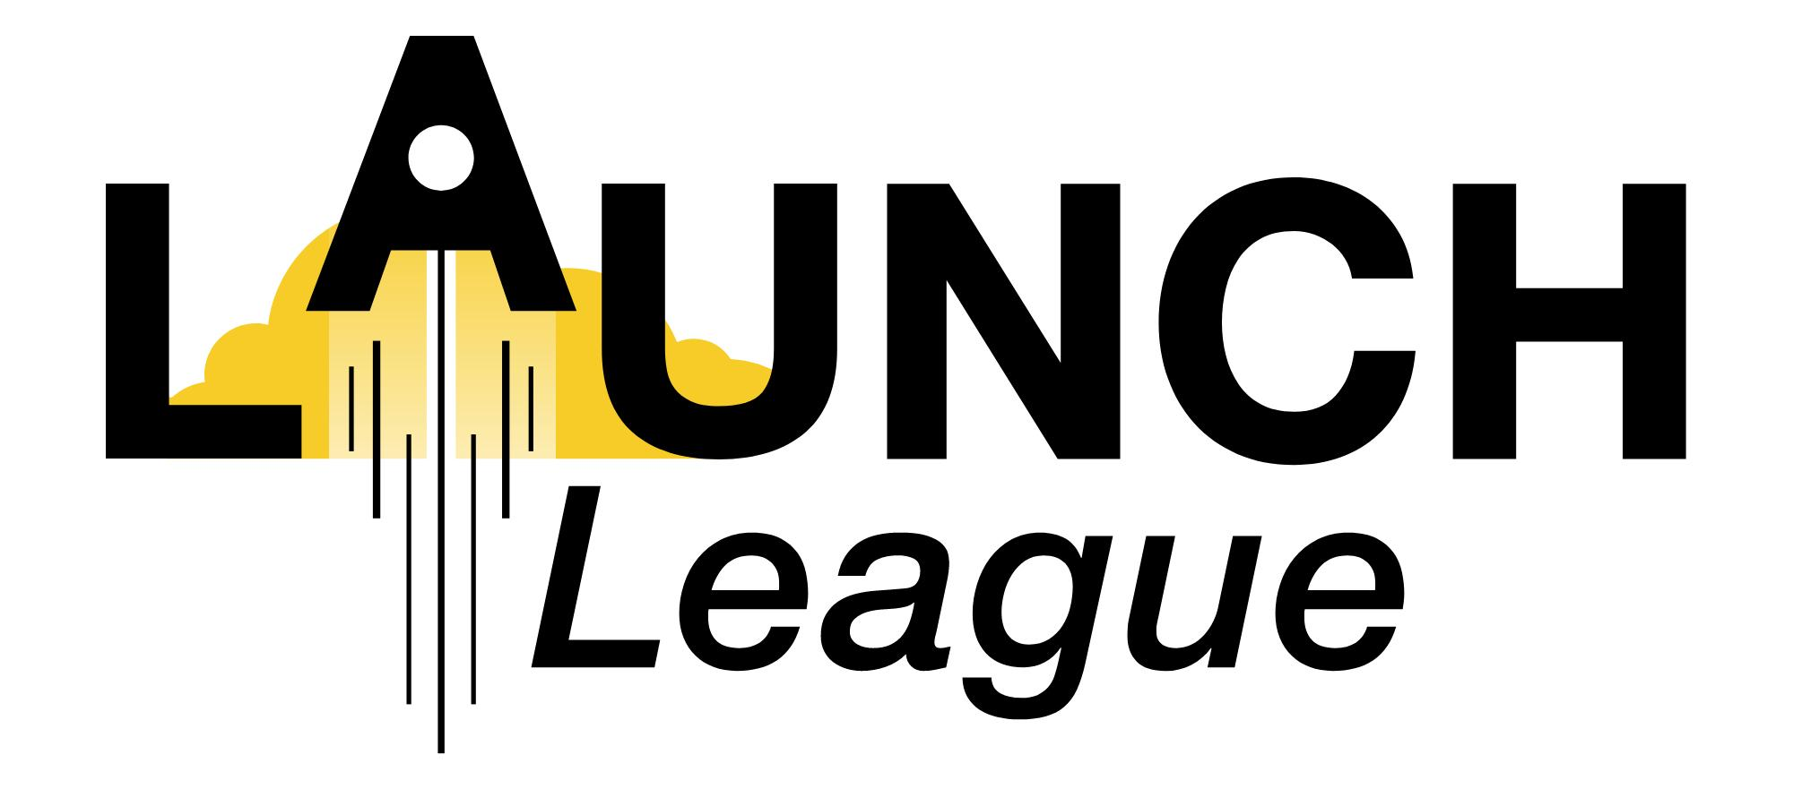

NAME:
CITY:
DATE:

1. On a scale of 1-6, how was your experience on the bootcamp? _____
1 = terrible
6 = I loved every second

2. On a scale of 1-6, did you learn something new on the bootcamp? _____
1 = no, I knew everything already
6 = yes, I learnt so much (too much for one day maybe!)

3. On a scale of 1-6, will you be able to apply what you learned on the bootcamp in your business? _____
1 = no, not at all
6 = yes, I can use the knowledge straight away

4. Which module did you find the most interesting? And why?
Module:

Why:

5. On a scale of 1-6, how useful was the Tech Tools modules for you? _____
1 = not useful at all, I knew all of this
6 = very useful, will start using these tools immediately

6. What do you hope to learn/ do in the meetups?

7. How likely are you to recommend this programme to a friend/ family/ colleague? _____
1 = I won’t recommend it
10 = Yes! Yes! I will definitely recommend it!

