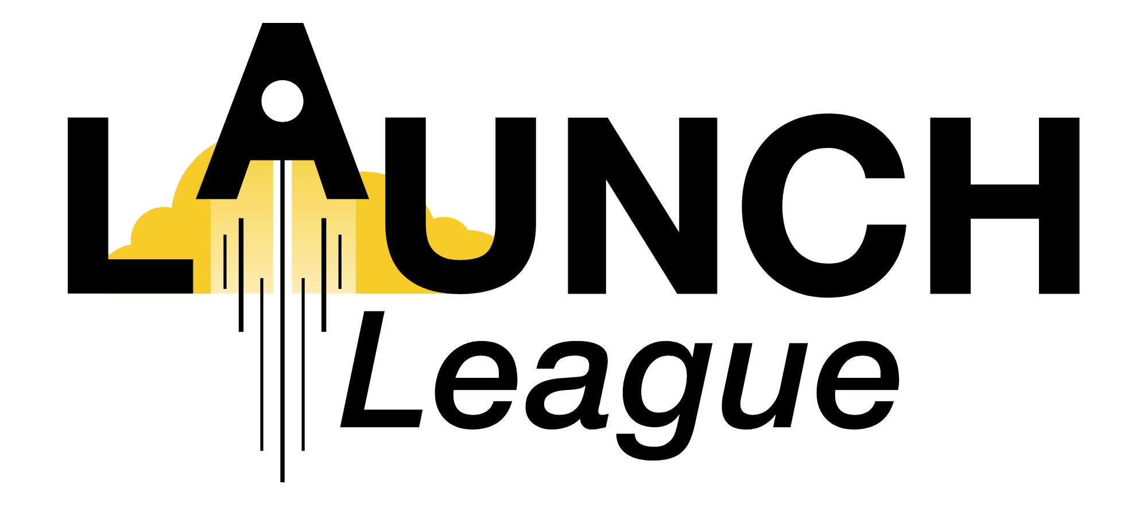

MENTOR SLA TEMPLATE

Organisation name and details
(that is employing the mentor)

{HUB LOGO}

MENTOR AGREEMENT

Mentor name and details
(mentor)

Company Name
Registration No.
Physical Address
Contact No.
Contact Person
E-mail Address
Invoices to be sent to
(the "Company")

and

Contractor Name
Identity/Passport/Registration No.
Physical Address
Contact No.
E-mail Address
(the "Mentor")

This agreement is to provide services as a mentor. You have been selected to participate as a mentor because of your expertise and experience, and alignment with {organisation name}’s organisational values.

Role Description:
Your role as a mentor is to provide guidance, motivation, emotional support, and act as a role model to mentees, who are entrepreneurs participating in programmes at the {organisation name}. You will be required to meet (virtually or in person) with the entrepreneur(s) and provide feedback to the {organisation name} programme team on these sessions.

Please refer to annexure A for the ​​Services Schedule.
Please refer to annexure B for the Fees Schedule.

- The contents of the mentor and mentee sessions are confidential and the relevant details of the sessions should only be shared with the programme management team and never externally. The mentee reserves the right to ask for full confidentiality of certain personal details. The mentor is to use their reasonable discretion on what to share with the programme team.
- The mentor should not become operationally involved in the mentee’s business, nor give direct instructions on what to do. The {organisation name} is not responsible for any advice or direction administered by the mentor and the mentor indemnifies {organisation name} to the fullest extent in this regard.
- The mentor services will continue for the duration stipulated in the service schedule. The mentor is welcome (and encouraged) to continue to act as a mentor or advisor for the mentee past the duration of this agreement, but this is at their own discretion, risk and cost.
- The {organisation name} and mentor have the right to terminate this agreement immediately on written notice to the other party, if there is reasonable cause for concern regarding ability to provide services.
- The mentor must comply with all applicable laws, including the Protection of Personal Information Act, 2013.
REQUIREMENTS DEFINITION, DESCRIPTION & SCOPE
As a {Organisation name} mentor, you will be required to perform the following tasks:
- Attend a mentor training session and engage with any mentorship guidelines and resources provided. x hours will be required per month/ over the course of the programme for a period of x months.
- Meet with your allocated mentee at an agreed-to frequency for at least one hour, either online or in-person.
- Provide the programme manager with feedback on how the session went, submitted via the provided Google form. This feedback should include specific challenges that the entrepreneur is facing, and recommendations for further development. The purpose of this reporting is to allow the programme manager to understand where the entrepreneur may be getting stuck and to provide additional support. This reporting may be shared with the programme partner/ funder as required.
- If relevant, provide a short report at the end of the mentorship period to include in the overarching programme report.
- The mentor’s photograph and name may be utilised in {hub name} or {programme name{ external communications, if consent was provided.

The mentor undertakes to act in the best interests of {organisation name} and not to bring the name of {organisation name} into disrepute.
FEES & CHARGES
The mentor services provided will be paid for at Rx per hour. Any time committed over and above the agreed-to commitment will not be compensated.
The mentor is liable for all tax levied on it in respect of the payments made to it in terms of this agreement and indemnifies {Organisation name} to the fullest extent in this regard.
or
This is a volunteer agreement and the mentor will not be financially compensated for any time committed.

SIGNED by the parties as follows:

For: | THE COMPANY |  | For: | THE MENTOR
Signature: |  |  | Signature:
 | who warrants that he / she is duly authorised thereto |  |  | who warrants that he / she is duly authorised thereto
Name: |  |  | Name:
Date: |  |  | Date:
Place: |  |  | Place:

