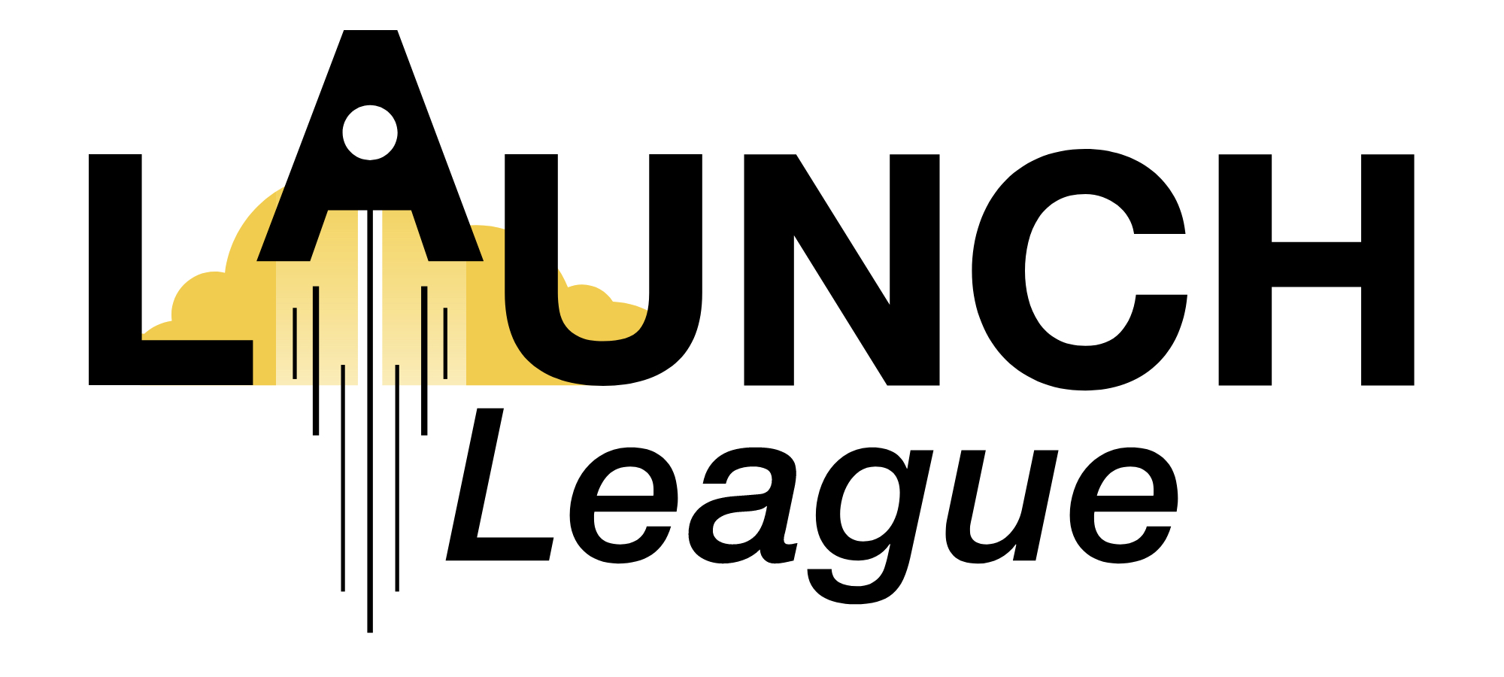
MODULE 2 EXERCISE
- Customer Pathways-

1. What are the various pathways that you could use to reach your customers?

Remember to think about what pathways your customers already use and are familiar with.

Referring to the following list of pathways:
- Social media
- Word of mouth
- Referrals through a partner business/ organisation
- Traditional media: TV, newspaper, radio
- Online advertising (Facebook or Google ads)
- Newsletters & email marketing
- Billboards, posters & flyers
- Website
- Platform or direct sales

Now, please fill out the below table:

1.1. Choose 4 key pathways that you think would be best to use to reach your customers

1.2. Note what the function of the pathway is – marketing or sales or delivery of product or service)

1.3. Describe how you’ll use each pathway in more detail.

Remember you need a mix of functions to make sure you not only tell your customers about your business but actually get the product or service to them to use or buy!

And, if you have users (people who use your product, but aren’t the ones paying for it), you might need to think about the pathways that you need to use to reach them and how these will be different from those you use for your paying customers.

 | Pathway | Function | Description
1
2
3
4

2. What will you need to do to start using these pathways in your business?
For example, if you are going to use social media you might need to set up business accounts; or create a website or perhaps enter into a partnership.

Now, write the main pathways you will use to reach your customers and deliver your product/ service in the Pathways block on your canvas.

